**Netflix Data Analysis**

Netflix is one of the largest providers of online streaming services. It collects a huge amount of data because it has a very large subscriber base.

We can analysis a lot of data and models from Netflix because this platform has consistently focused on changing business needs by shifting its business model from on-demand DVD movie rental and now focusing a lot about the production of their original shows.

In this Project, you will take a look at some very important models of Netflix data to understand what’s best for their business. Some of the most important tasks that we can analyze from Netflix data are:

1. understand what content is available
2. understand the similarities between the content
3. understand the network between actors and directors
4. what exactly Netflix is focusing on
5. and sentiment analysis of content available on Netflix.

The dataset we use for the Netflix data analytics task consists of TV shows and movies streamed on Netflix as of 2019. The dataset is provided by Flexible which is an engine of third-party research available on Netflix.ans sloved below question and create visualization into Power BI or Tableau .

#### 1.Top 5 Actors

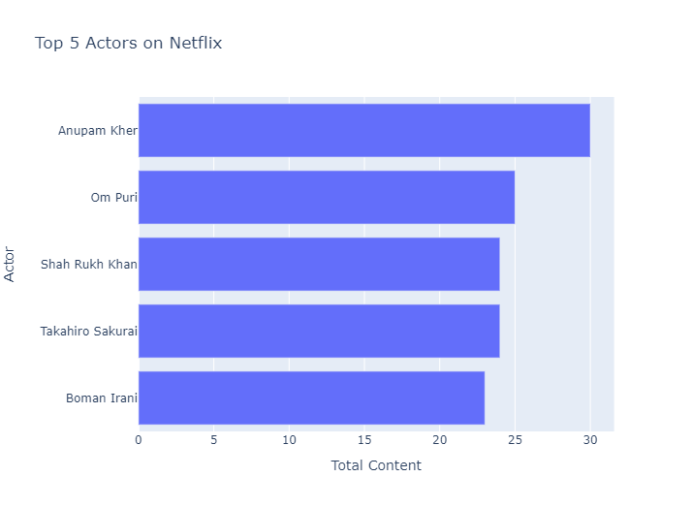

#### 2. Top 5 Directors

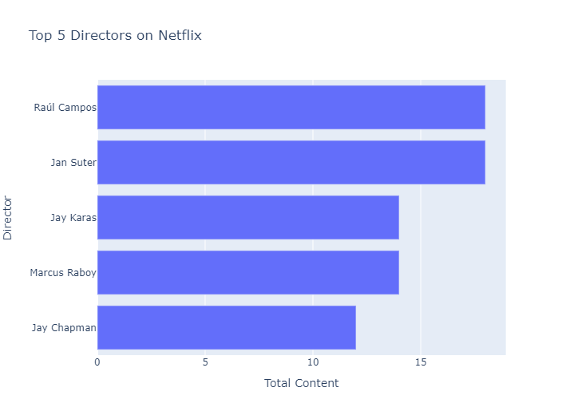

3. Analyz from this data is the trend of production over the years on Netflix

.

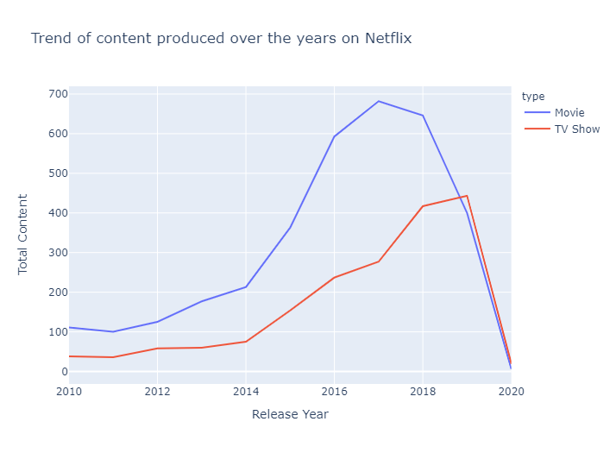

4. Analyz the sentiment of content on Netflix.

